**AWS (EC2) Installation steps for Linux instance**

**Requirement** – Amazon web service account

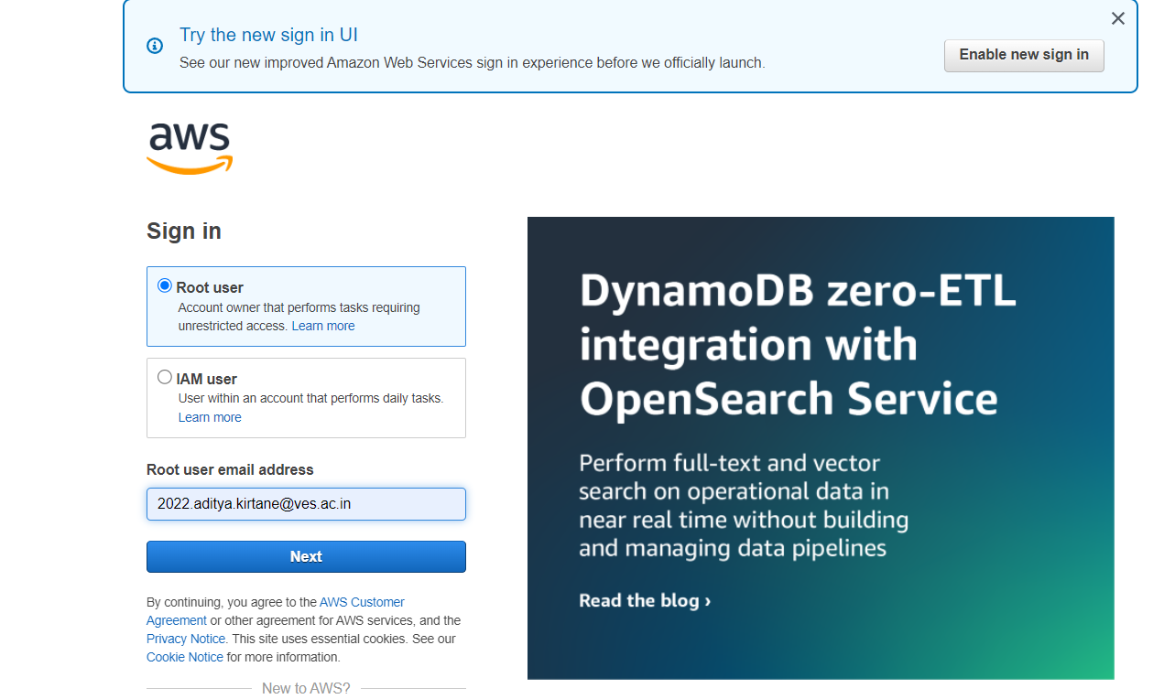Login

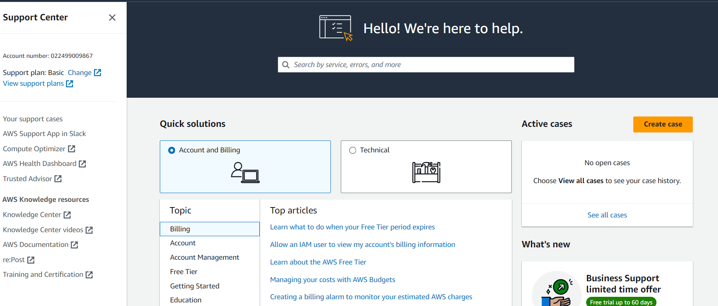Open AWS Services

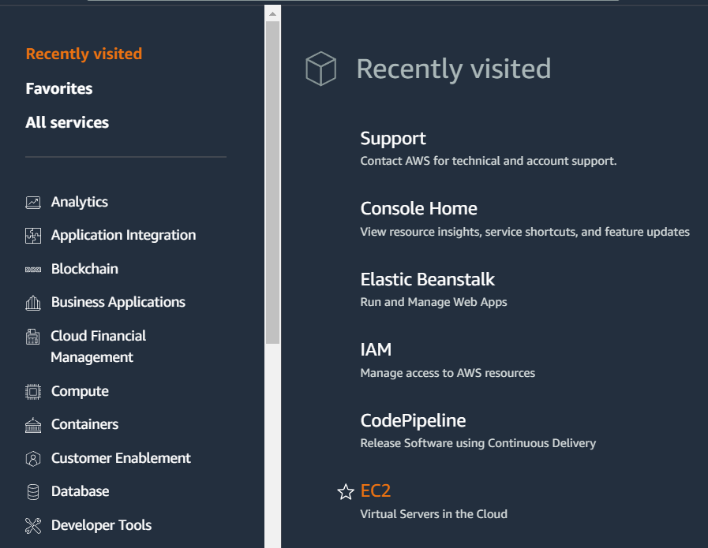Select EC2

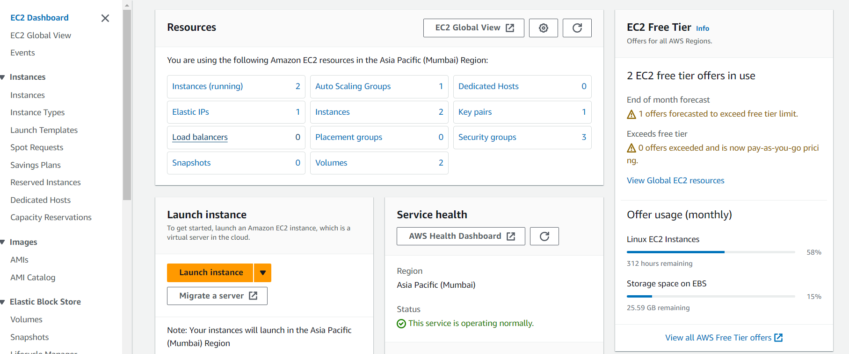**CLICK ON instance (running) in above screen**

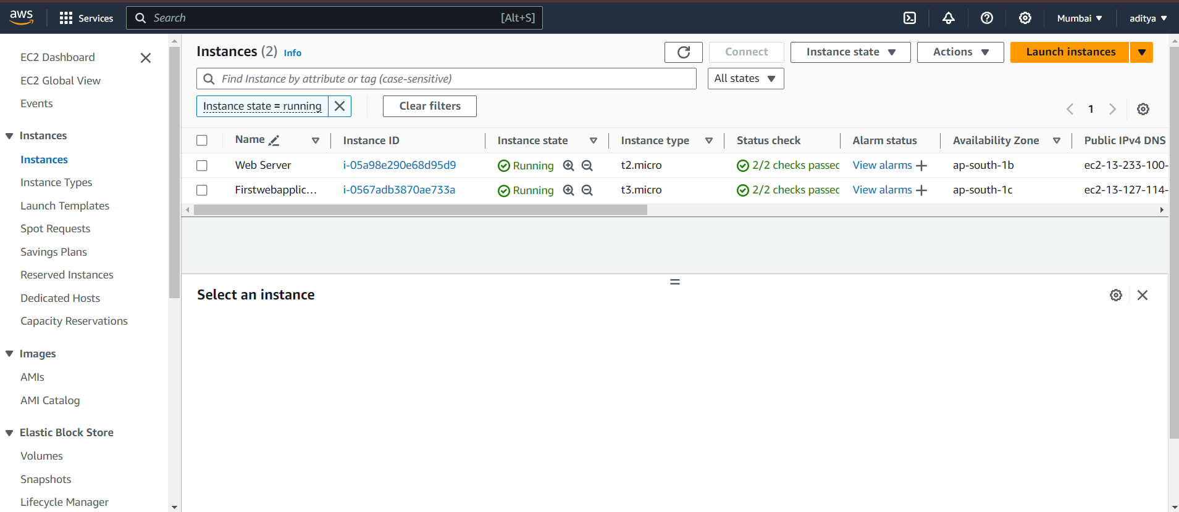On above screen click on launch Instances

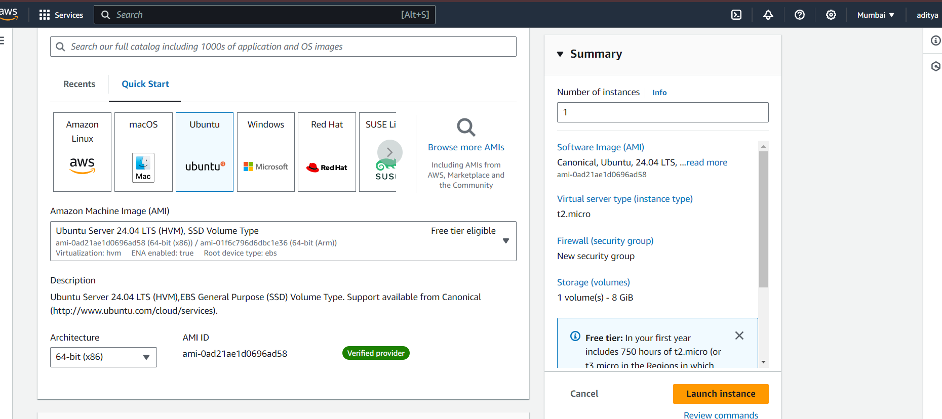Select **Ubuntu server 20.04**

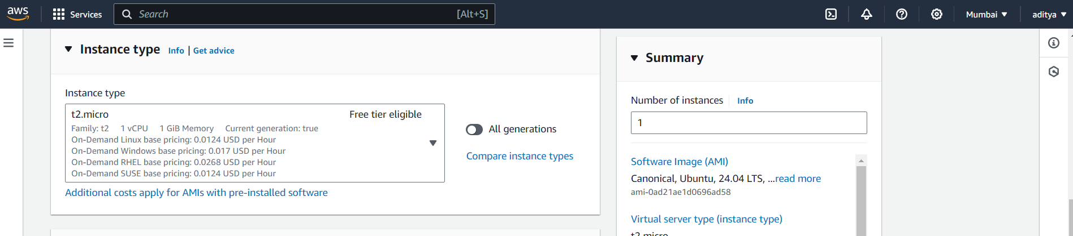Select **free tier eligible** and click on button – Next: configure instance details

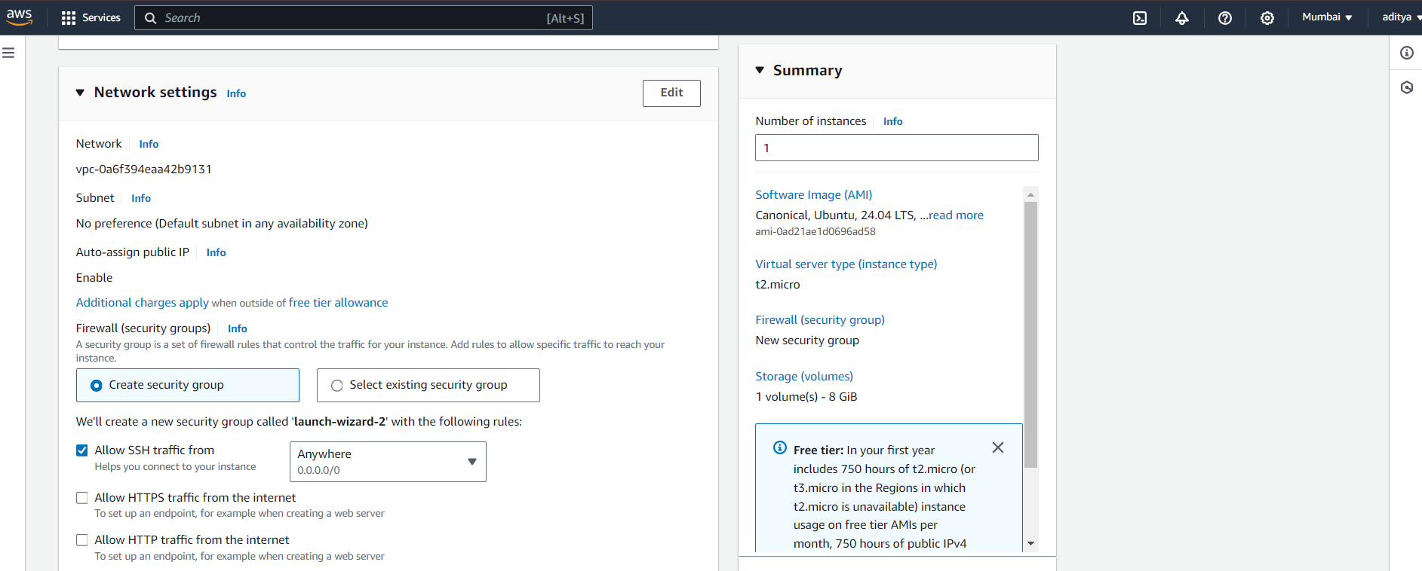Don’t change any setting directly click on button – Next: Add storage

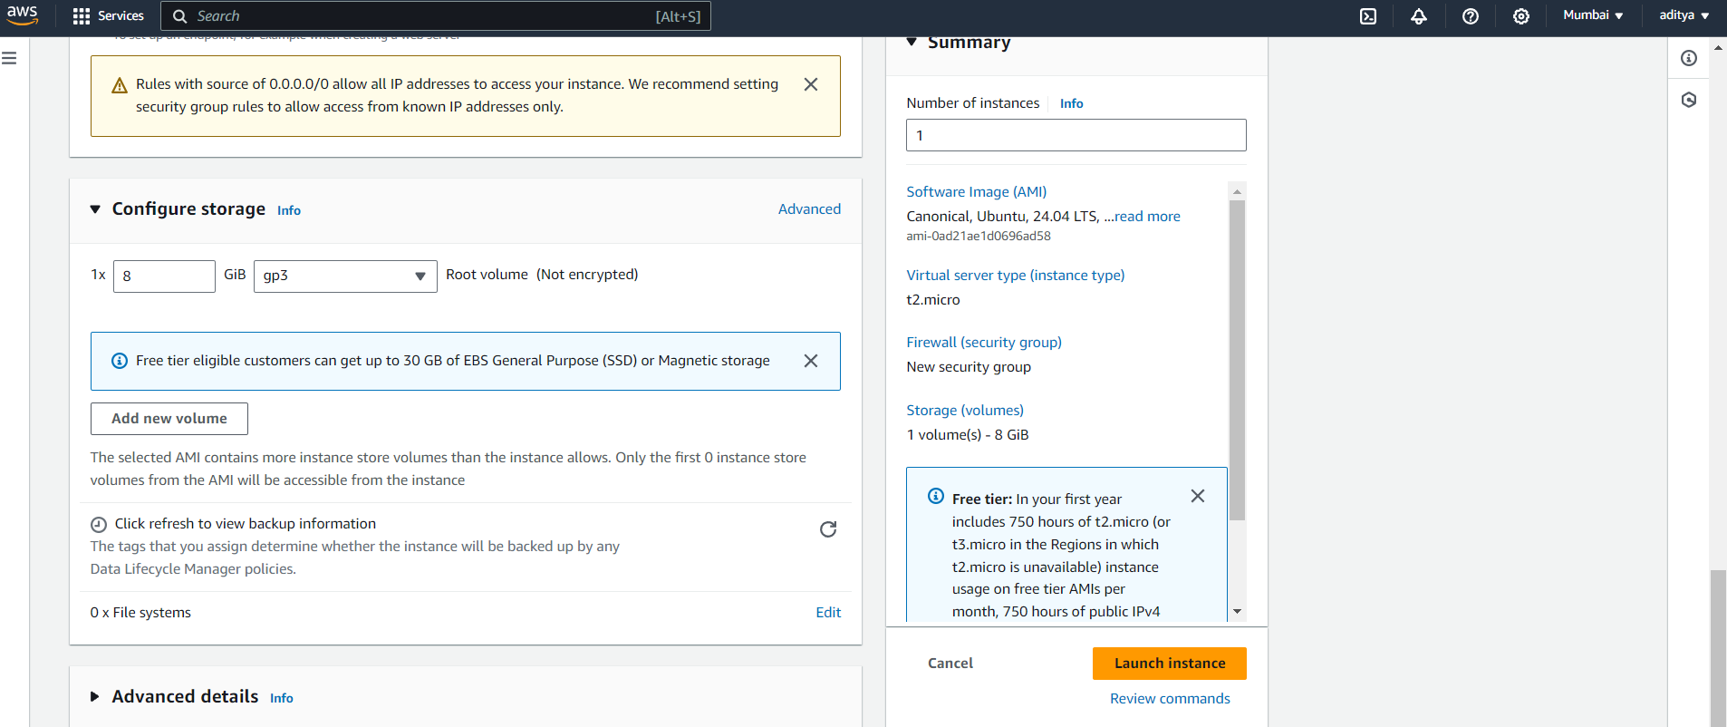Check Volume type: General purpose SSD (gp 2) and then click on button – **next: Add Tags**

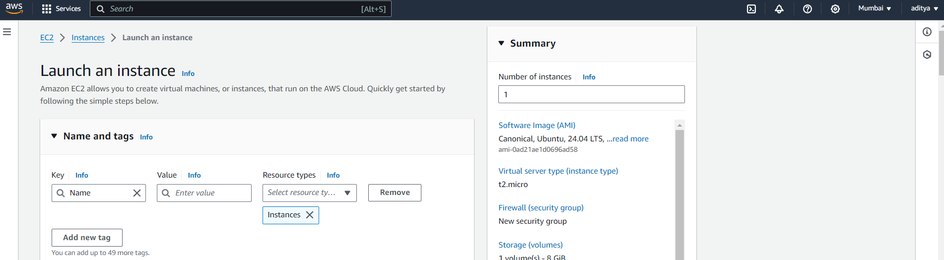Need to add key so click on Add Tag

In key tab give any name, value – database and then click on Button- **Next: Configure Security Group**

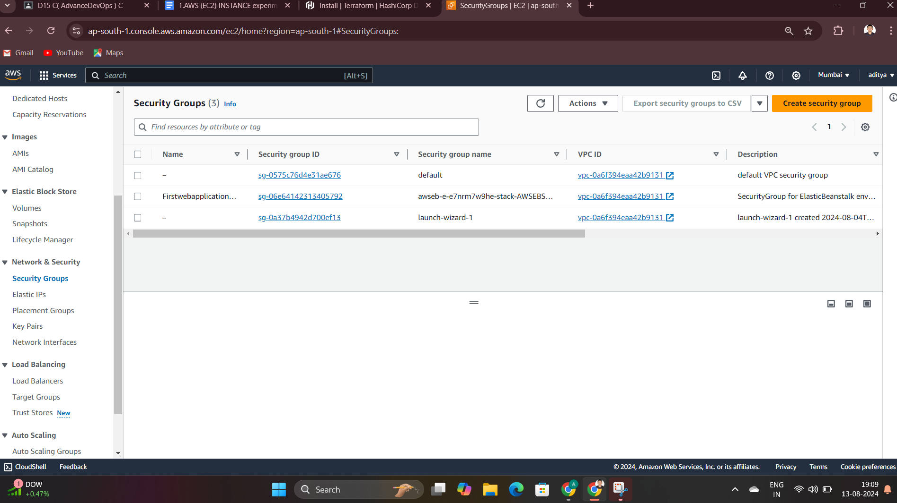Here we need to change Security group name- provide any name like im providing db_sg (example database_security groupso we use shortcut)

In description again copy same name instead of Launch_wizard_1 only remaining line keep as it is –**step 1-**

Security Group name- **db_sg**

Description- **db_sg created 2020-12-22T 10:51:21:442+5:30**

Step2 – click on **Add Rule Button – select all Traffic**

Step3- Set Source tab **– Anywhere this is for your subnet**

Step 4 – click on button**: Review and Launch**

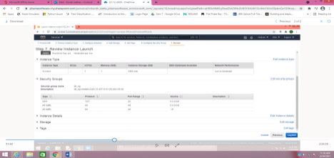One warning on this screen but ignore that and click on **Launch**

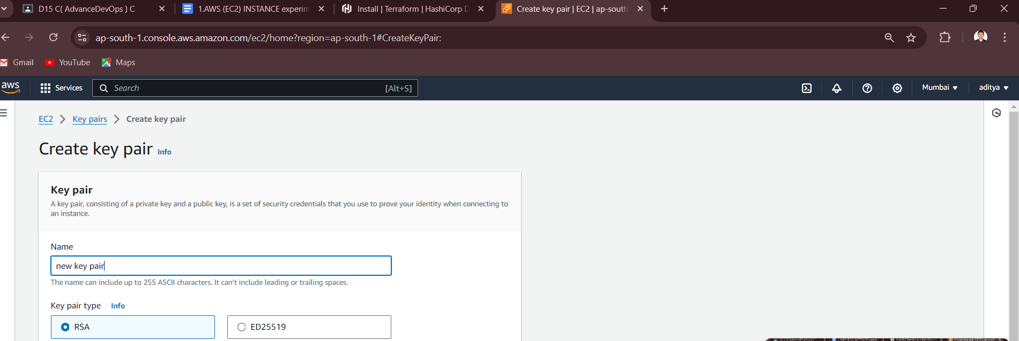Click on Create a new key pair

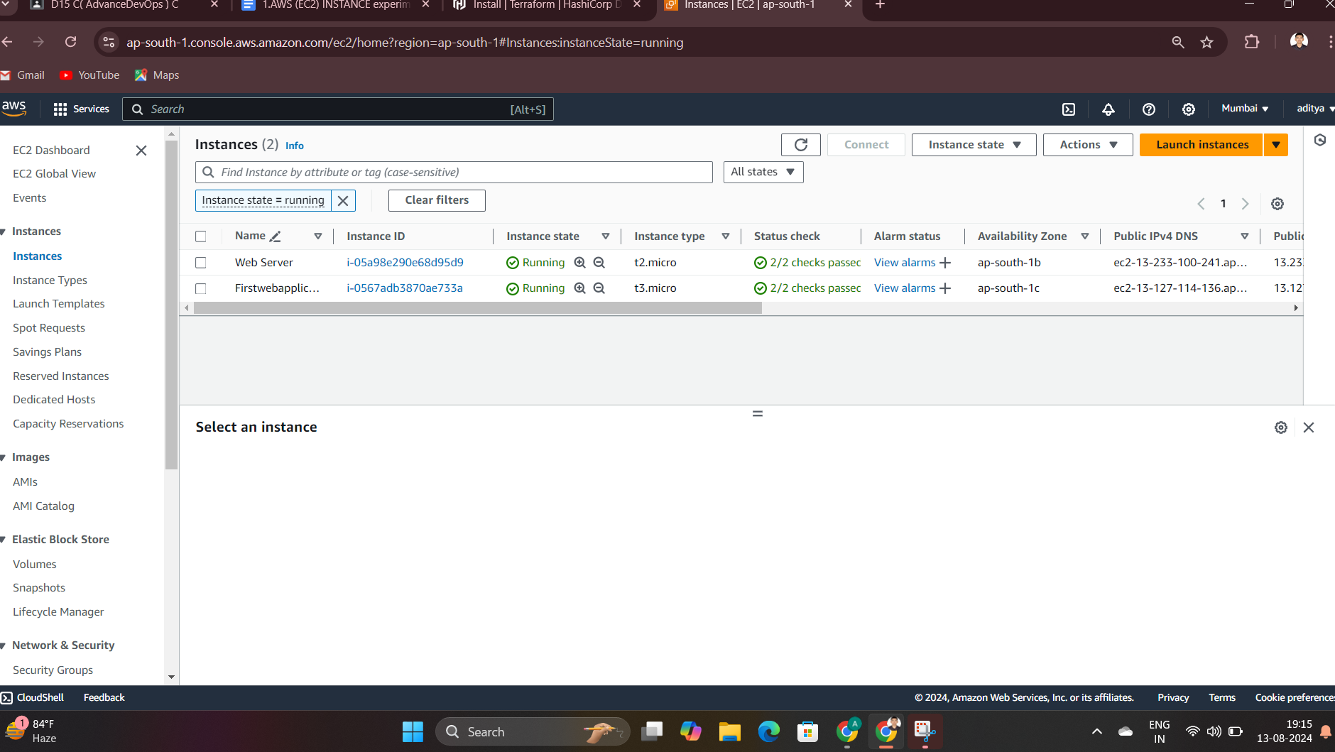Insert key pair name anything like – test , now click on Download key pair(security permission file download it is encrypted file)

Click on I acknowledge box and click on **Launch Instances**

You get the mgs in green color – click on View Instances

Click on refresh button because we need **Status check tab** – **2/2 check pass**

S

e

l

e

c

t

E

C

2

Select check box which in present at before name DATABASE and click on **connect** Button

S

e

l

e

c

t

E

C

2

Here you can change the user name if you want – like **db_sg1** Step- click on **Connect**

Some time it display error because of bandwidth issue ,so that time simply click on **retry** button.

Next step perform some command on your Ubuntu server-

$ sudo –I (root login)

# apt update (update your system)

# top (table of processes, which are the running processes in our system and also check usage management)

Press Ctrl+c or press q for end top command.

# history

# vmstat (virtual memory static ,how much memory in the buffer,in the cache,what is in the input,output,systems and the cpu)

# df (disk file system)

#df –kh (k-kiolbyte h-human readable)

#whatis df (using whatis command take help from system)

#df - - help (help command)

# ctrl + l (clear the screen)

#uname -a (information realted to ip, kernel version)

All are Validation steps for checking your EC2 instant working properly or not(check system performance).

# mkdir test

# ls

# cd test

test# touch file1 (create file)

# ls

# touch file2 file3

# ls

# rm file1 (remove file)

# ls

# rm file* (remove all files)

# ls

# cd ..

# ls

# rmdir test

# ls

#mkdirtest1test2test3

#ls

# rmdirtest*

# ls

S

e

l

e

c

t

E

C

2

S

e

l

e

c

t

E

C

2

select the checkbox which is available at the start of your name of instant , then click on Instant State Button on the top and select **Terminal Instance**

S

e

l

e

c

t

E

C

2

Click on Terminate

S

e

l

e

c

t

E

C

2

Again check EC2 dashboard Instances running = 0

Volume =0

Now click on Security group

S

S

e

e

l

l

e

e

c

c

t

t

E

E

C

C

2

2

Click in the checkbox at the starting of your name then click on **Action** button and select **delete security group**

Again check EC2 DASHBOARD now your security group = 1 only

Inscances (running) = 0

Volume = 0

Here you terminated your EC2 Instance.